TraceFP

User Guide

**User Guide**

* Introduction
* Basic interface
  + How to open a floor plan file (.fp)
  + How to open a wall sample file (.dq)
  + How to save modified floor plan file
  + Clear all data on screen
* Graphics rendering
  + Display wall samples, control points, and rooms
  + Refresh
* Basic floor plan manipulation
  + Basic point manipulation
    - Add point(s) to the floor plan
    - Merge and relocate a set of points on the floor plan
    - Remove point(s) from the floor plan
  + Basic room manipulation
    - Construct triangle(s) for a room
    - Remove triangle(s) from a room
    - Construct convex polygon(s) for a room
  + Undo / Redo
* Advanced floor plan manipulation
  + Points
    - Merge multiple points into one point
    - Clustering points
  + Lines
    - Align points to a linear line
    - Align points to a pair of orthogonal lines
  + Rooms
    - Add a point to a room and extend room borders
    - Split a triangle into multiple triangle along a point
    - Reduce number of triangles without changing coverage of rooms
  + Axis control
    - Align all lines to direction

**Introduction**

TraceFP is an application to manipulate floor plan files.

Floor plan files (.fp) uses triangles as basic building blocks of rooms. Each room is consisted of one or more triangles. Each triangle is assigned a room id. Different triangle can have the same room id, so that they can together represent an area that the particular room occupies. Each triangle must have its points based on control points, which is displayed as pink points on the screen.

The application also supports the use of wall samples files (.dq). Wall samples are displayed as blue points on the screen, as opposed to control points, which are pink.

**Basic interface**

**How to open a floor plan file (.fp)**

Click on the “open fp file” button. Select the corresponding .fp format floor plan file. It might take a while for the floor plan file to be read and rendered.

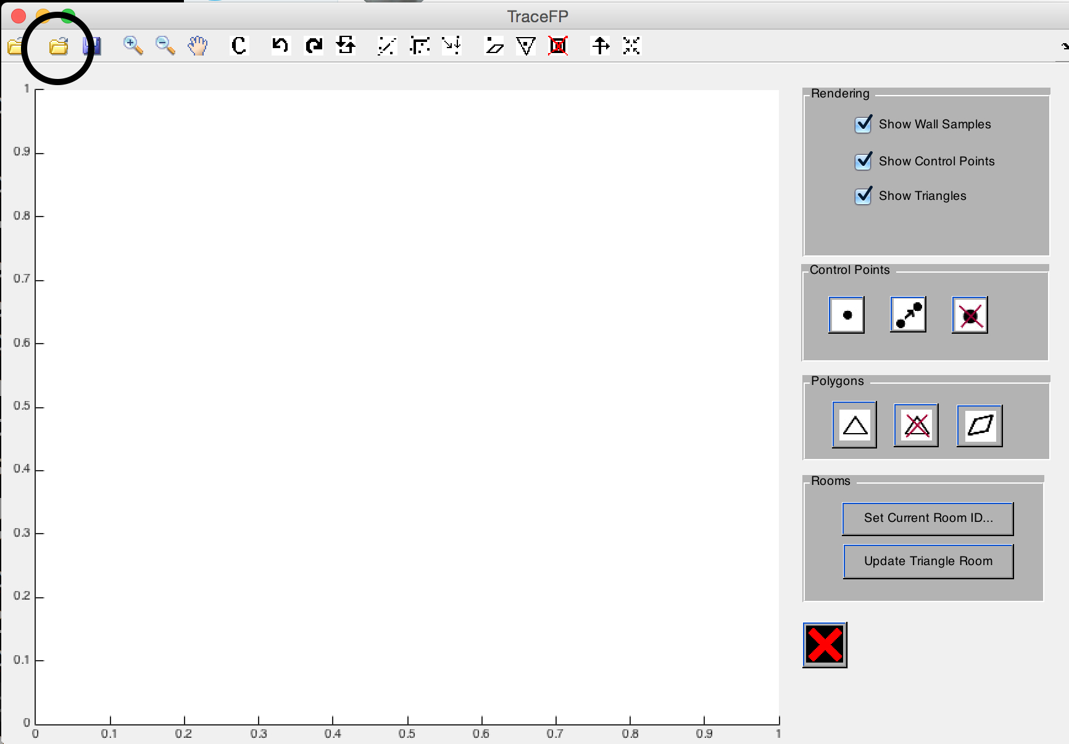

**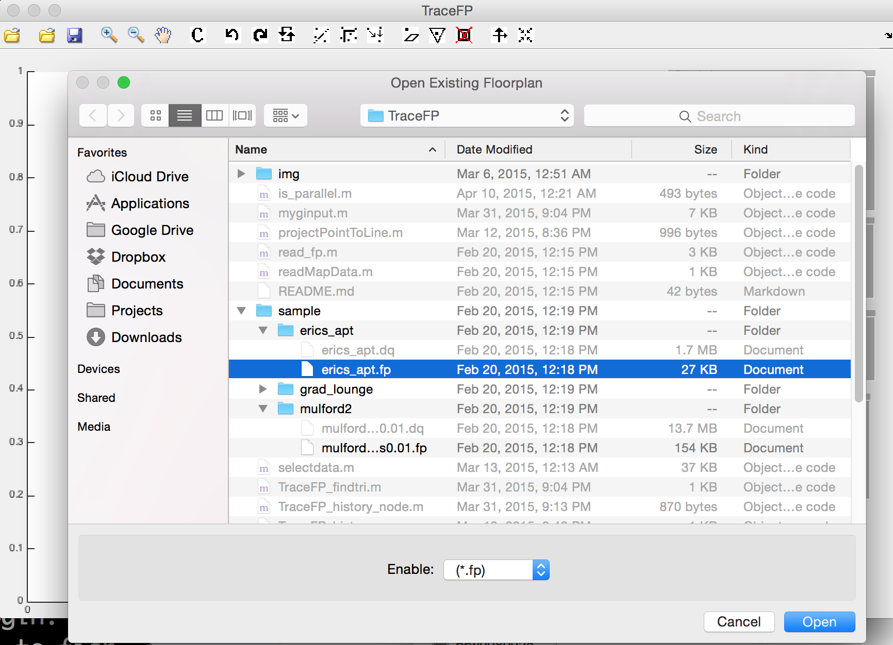****How to open a wall sample file (.dq)**

Click on the “open dq file” button. Select the corresponding .dq format wall sample file. It might take a while for the wall sample file to be read and rendered.

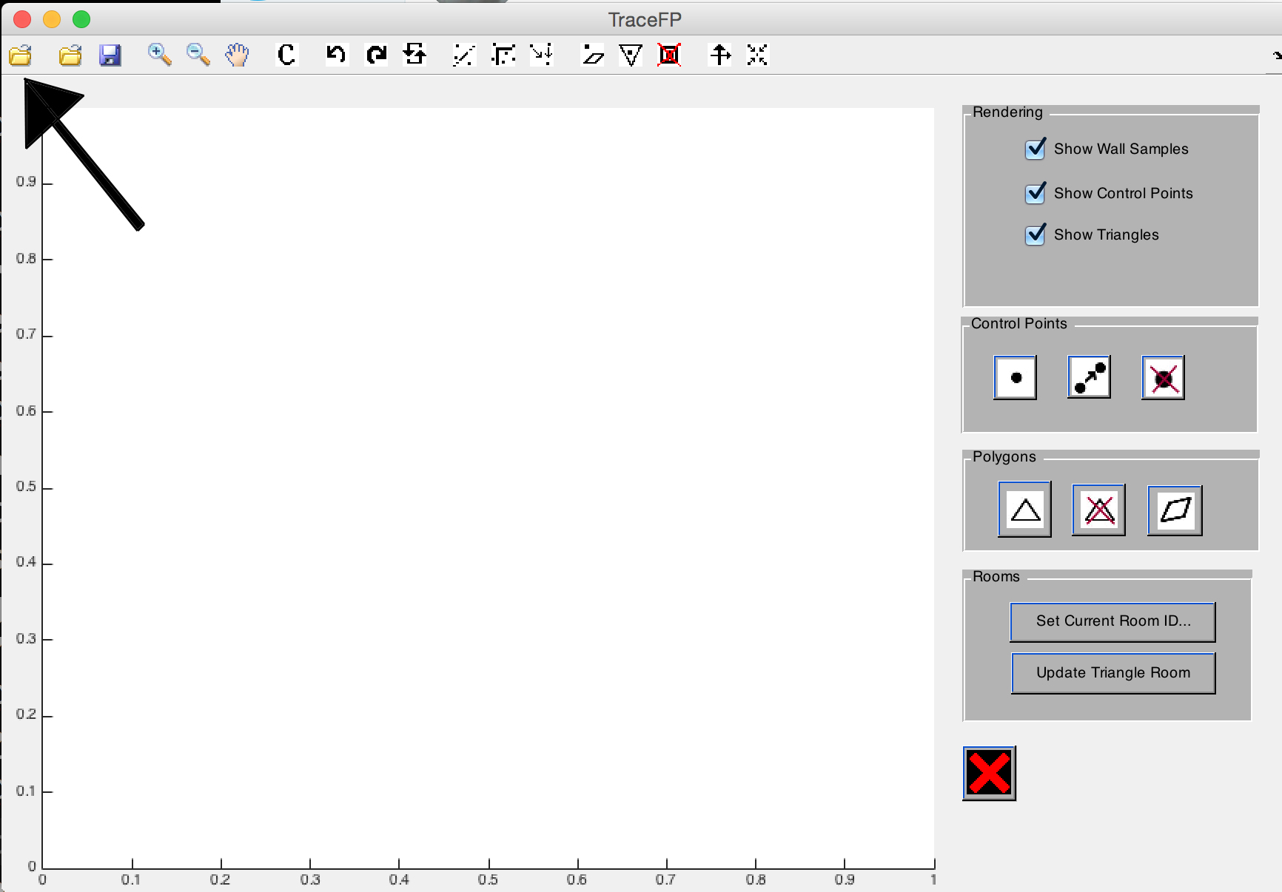

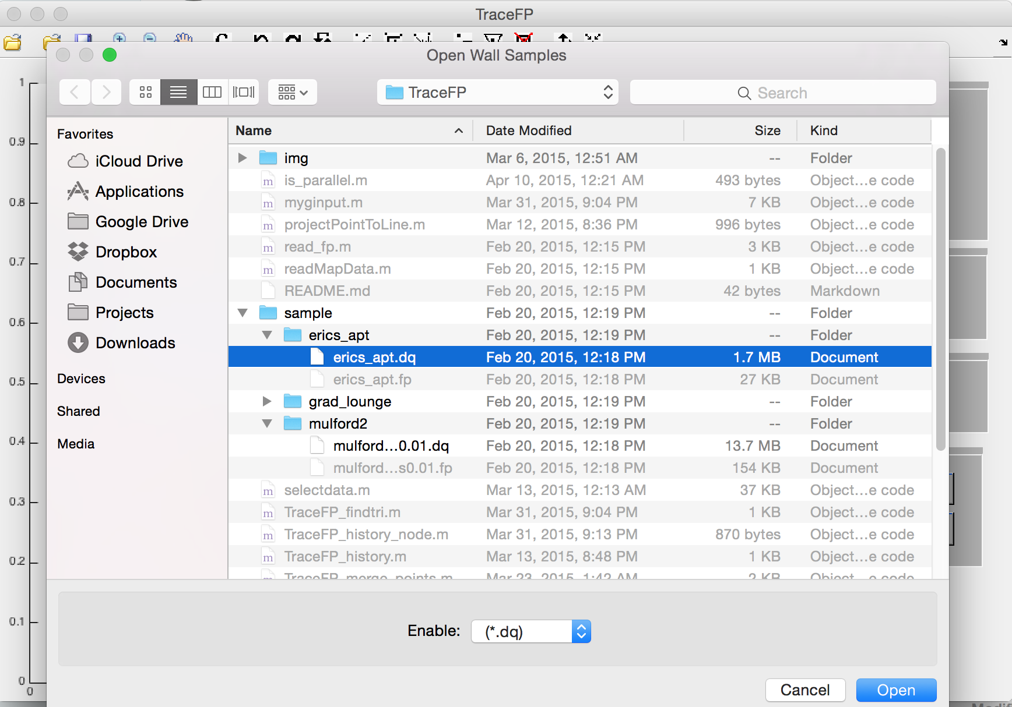

**How to save modified floor plan file**

Click on the “save fp file” button. If the file is newly created, the application will prompt you for path to create the file. Otherwise, the file is automatically saved to the original opened file.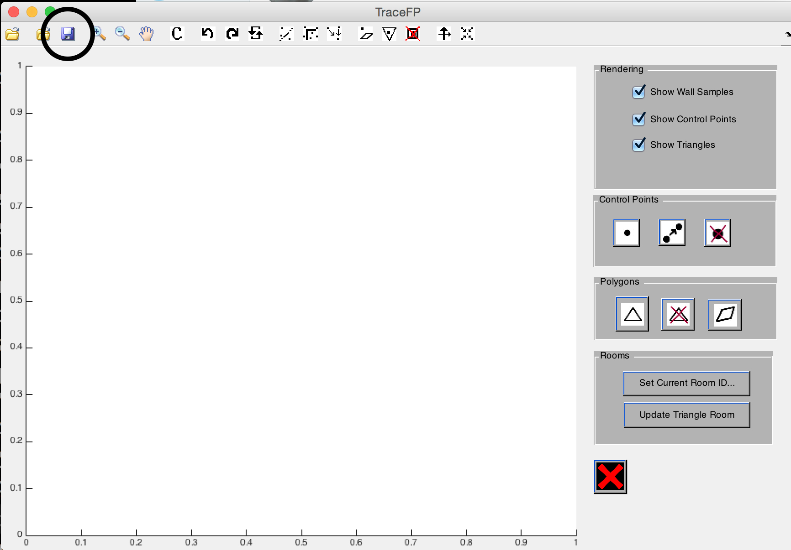

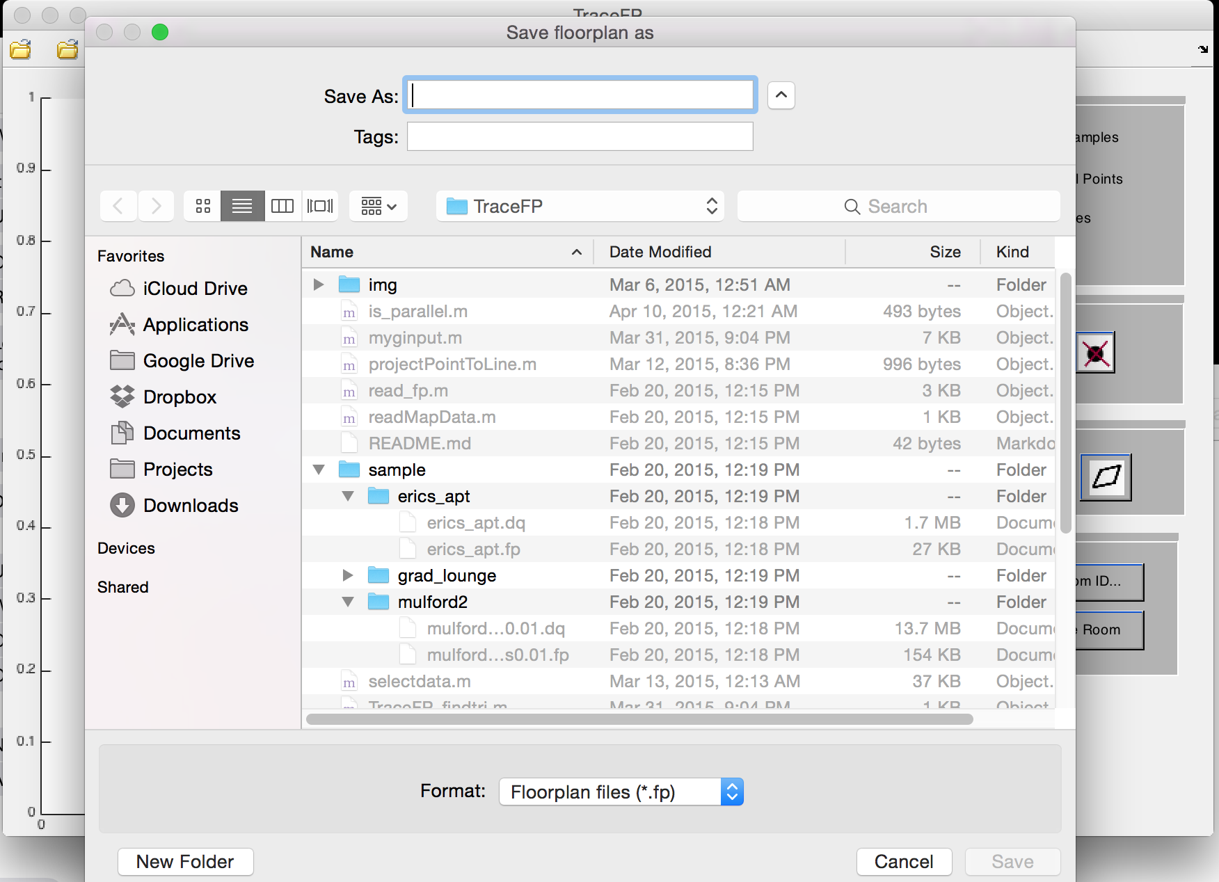

**Clear all data on screen**

If the “clear” button (as indicated below) is clicked, everything currently loaded on the screen will be cleared, including triangles, control points and wall samples.

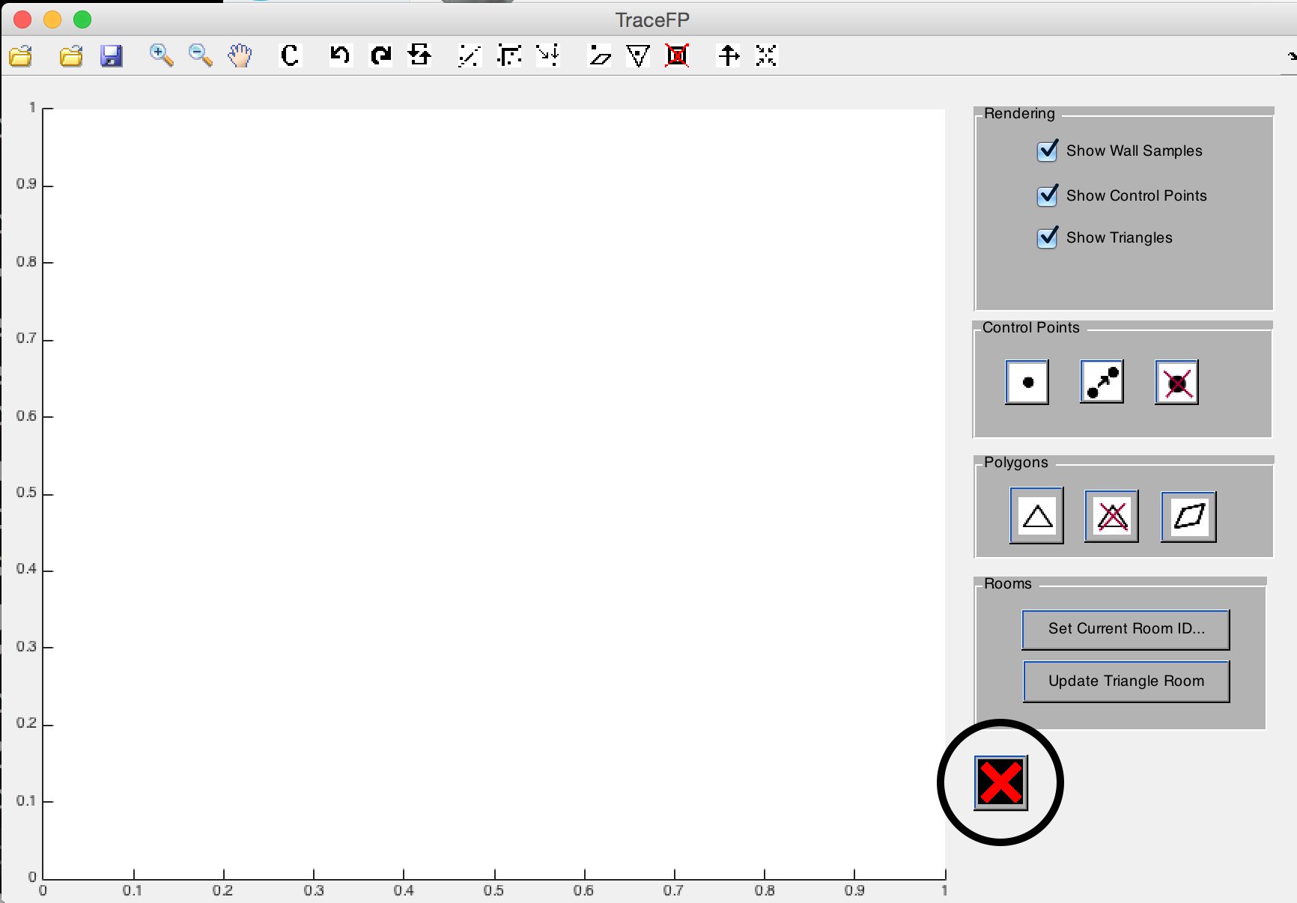

**Graphics rendering**

**Display wall samples, control points, and rooms**

The three checkboxes on the top right of the screen control whether to display wall samples / control points / triangles.

Unchecking “Show Wall Samples” checkbox (as indicated below) will hide all wall samples from the screen. However, the wall samples are still loaded so you do not have to reload wall sample file to show them again. Simply check the box again and hidden wall samples will appear on the screen. If the wall samples did not appear as expected, refresh the screen.

The other two checkboxes (as indicated below) work in exactly the same way but they hide control points and triangles respectively.

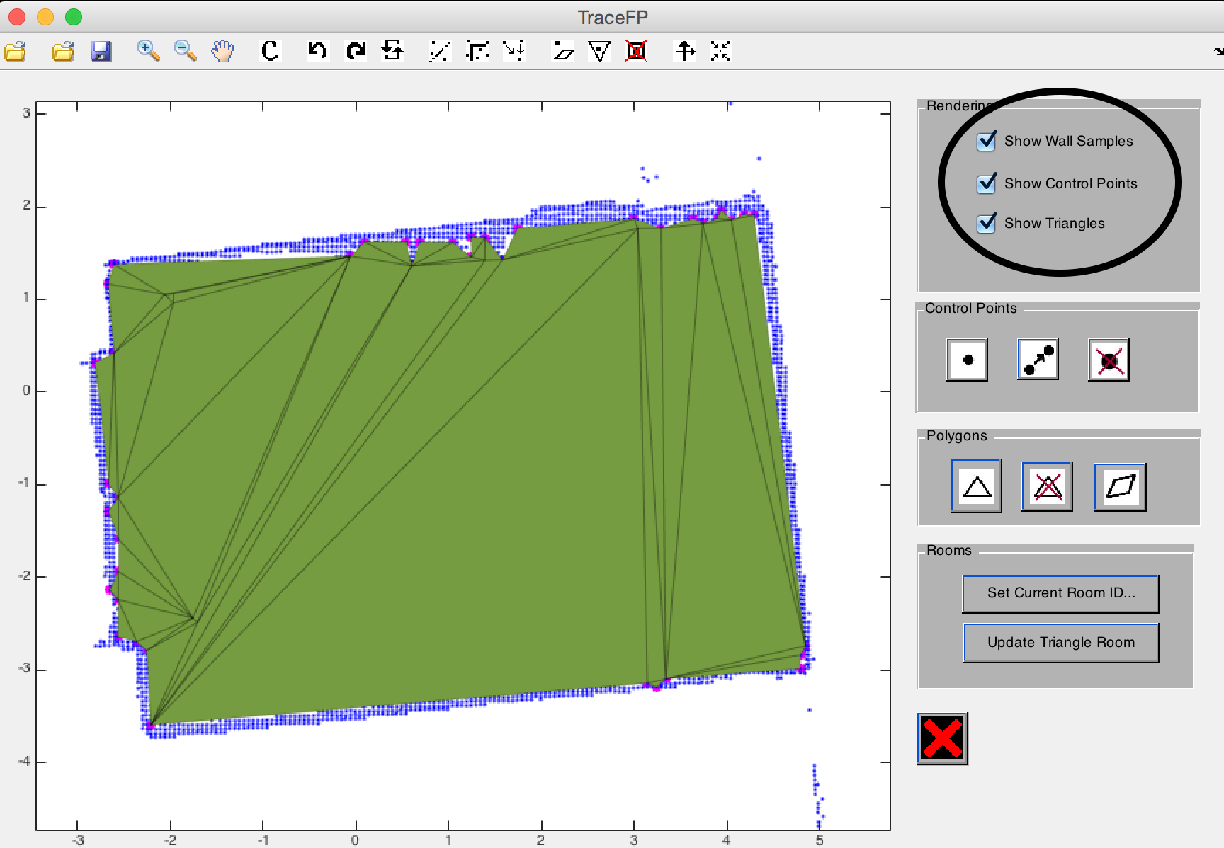

**Refresh**

The refresh button (as indicated below), is used to refresh the screen. Clicking the button will cause all graphics, including control points, wall samples and triangles to be re-rendered.

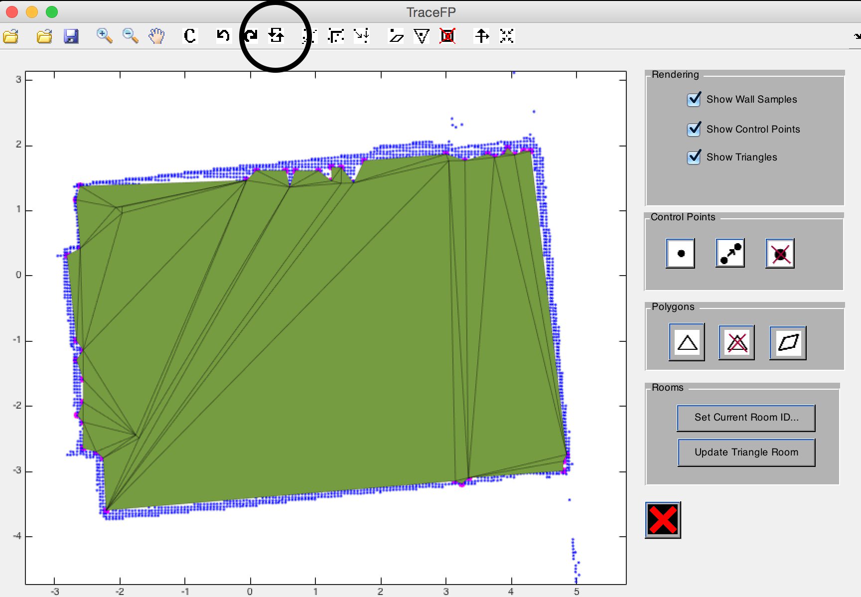

**Basic floor plan manipulation**

**Basic point manipulation**

**Add point(s) to the floor plan**

To add points to the floor plan, click on “add points” button (as indicated below) then click on points where you want to add a point at. After adding all the points, right click on the floor plan to stop adding points.

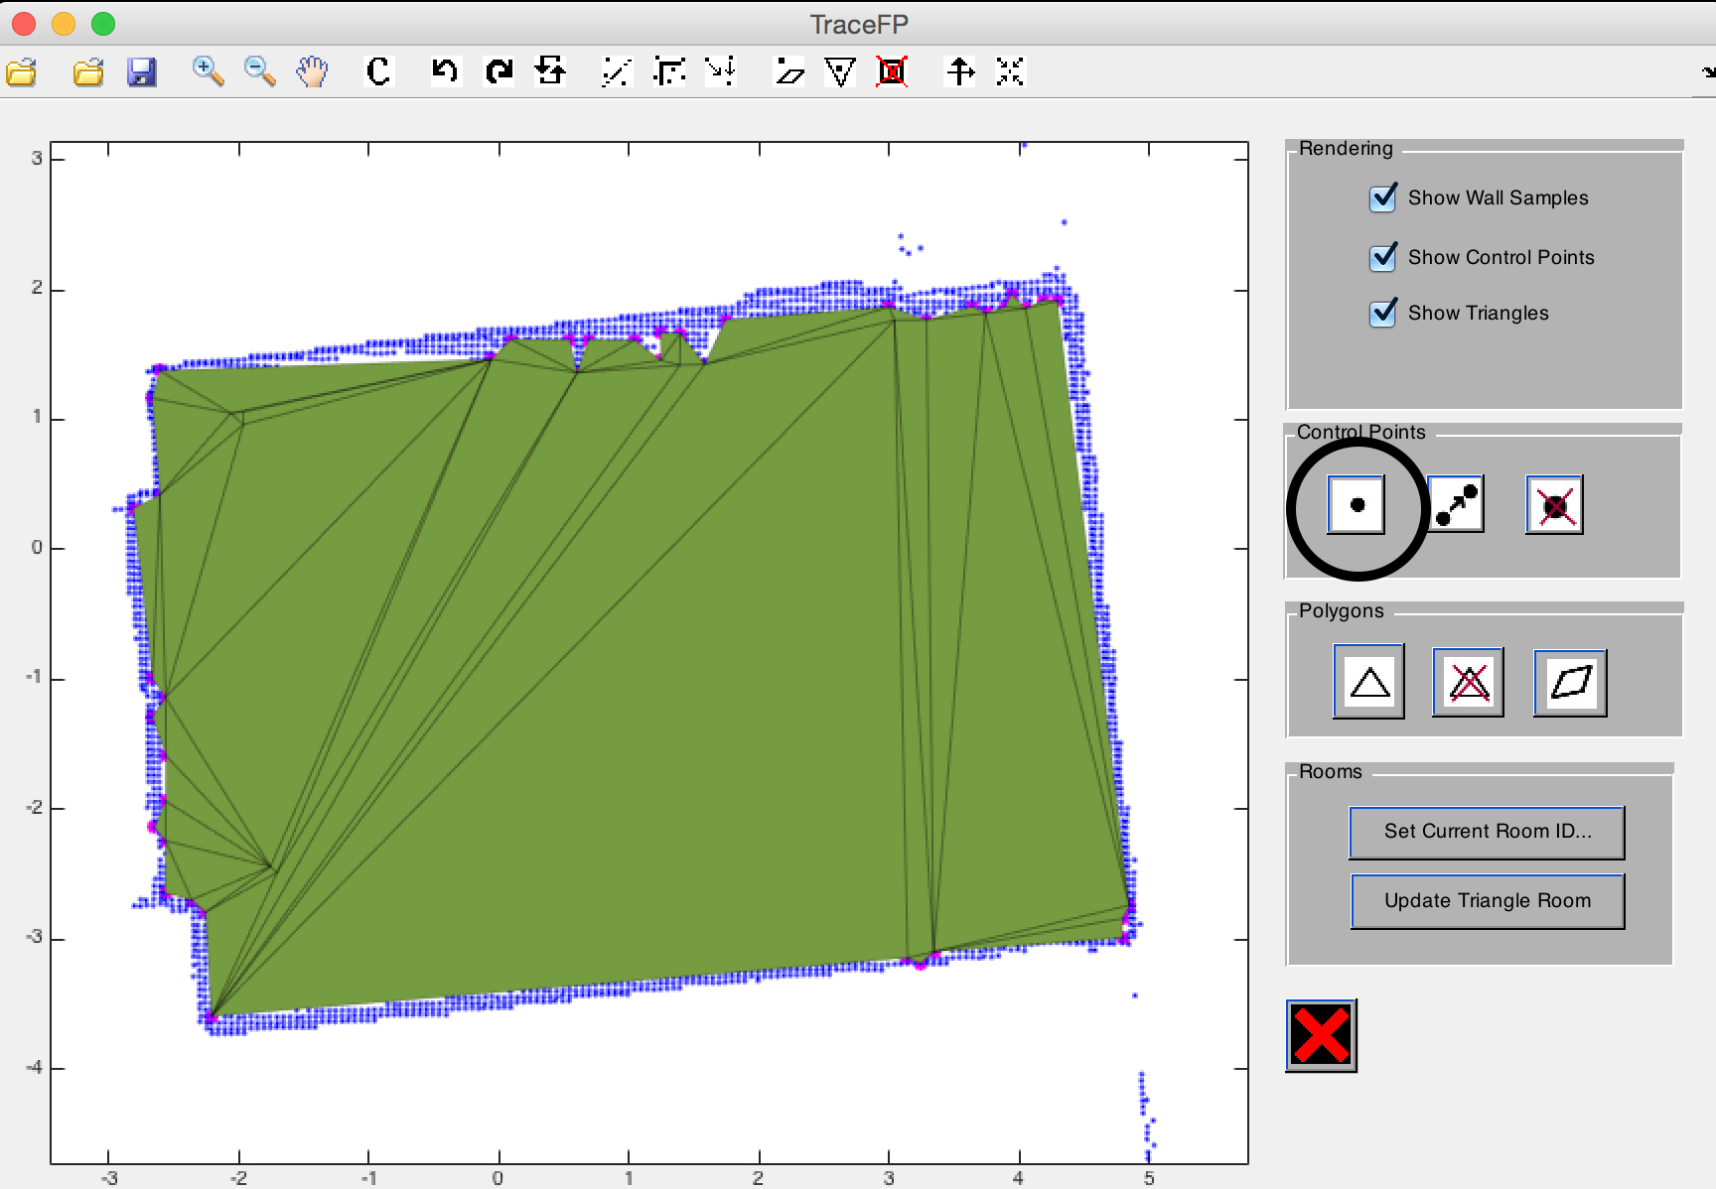

**Merge and relocate a set of points on the floor plan**

To move a point on the floor plan to another location, click on the “merge and relocate” button (as indicated below). First, select a point to relocate, and then select a new position to relocate this point to. User can exit move points by right clicking at any time.

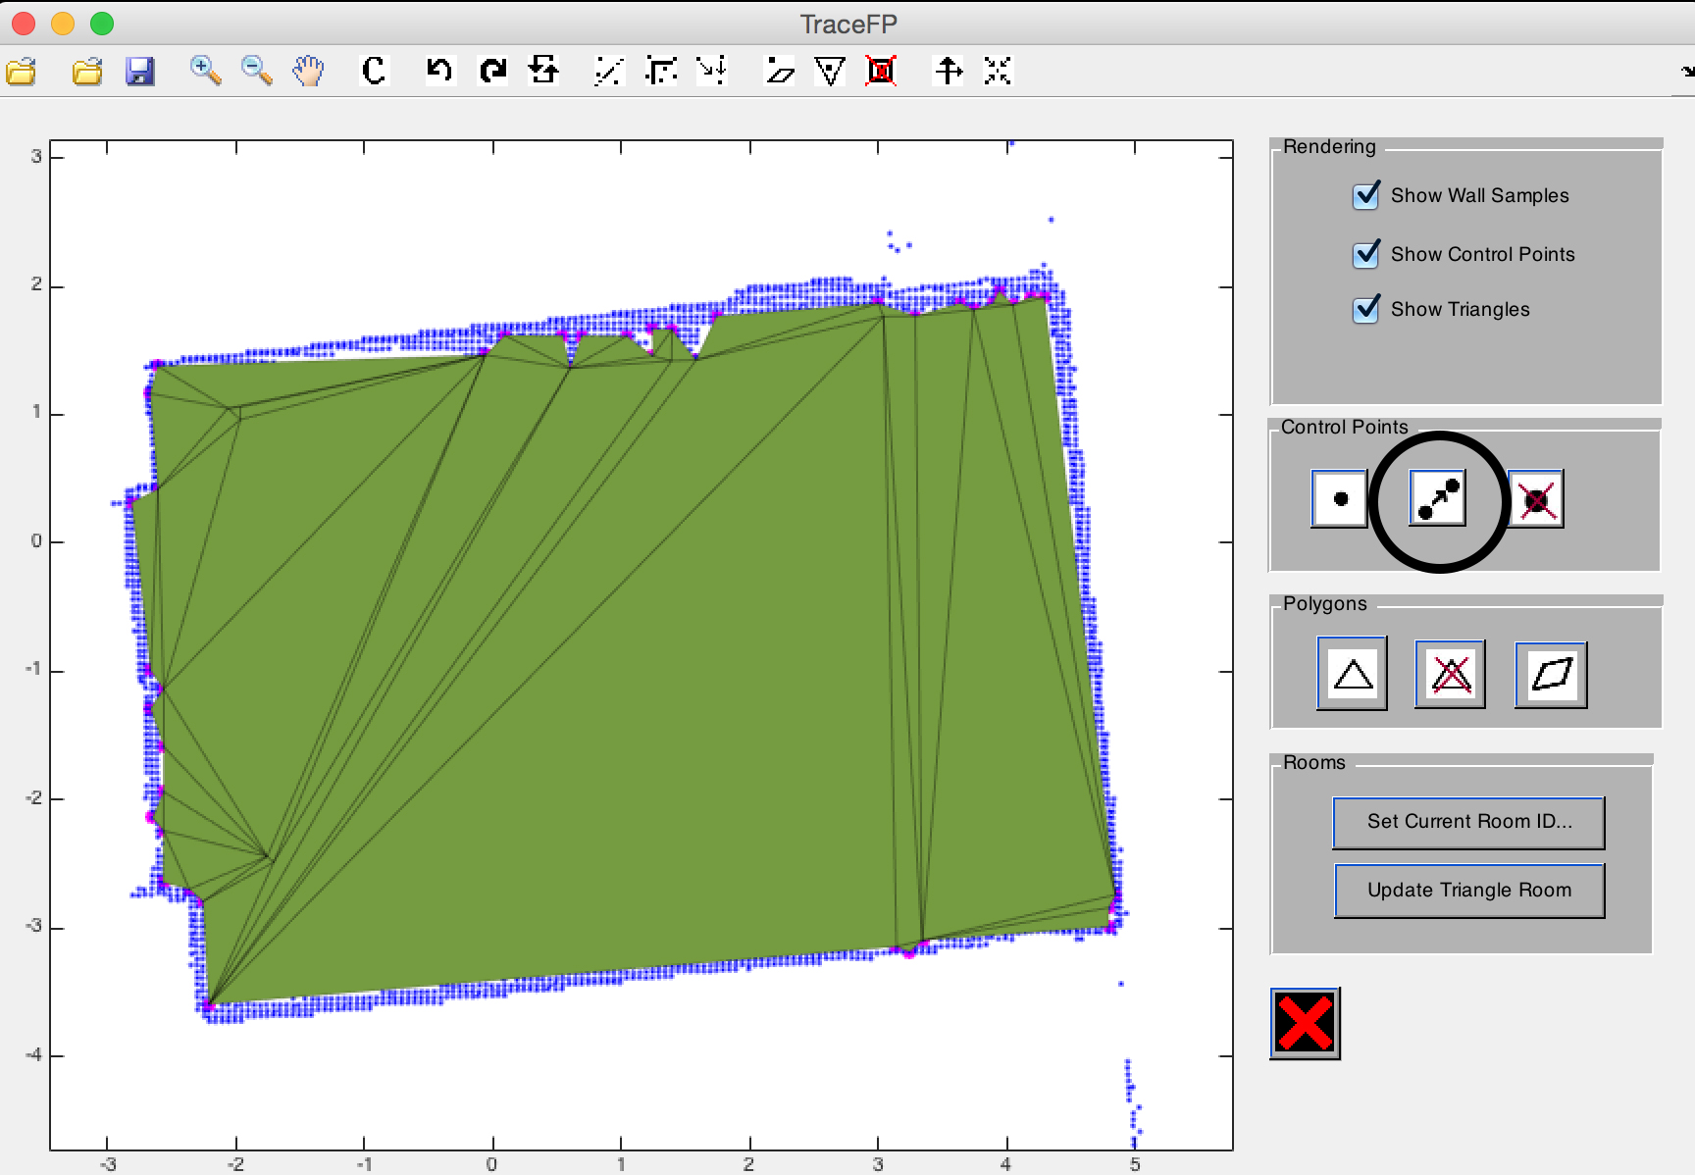

This button can also move a set of points to the same location, to select a set of points, click and drag the lasso tool over the floor plan. Selected points will be displayed as red points. Points will be first merged into one, and then moved to the indicated location. User can exit move points by right clicking at any time.

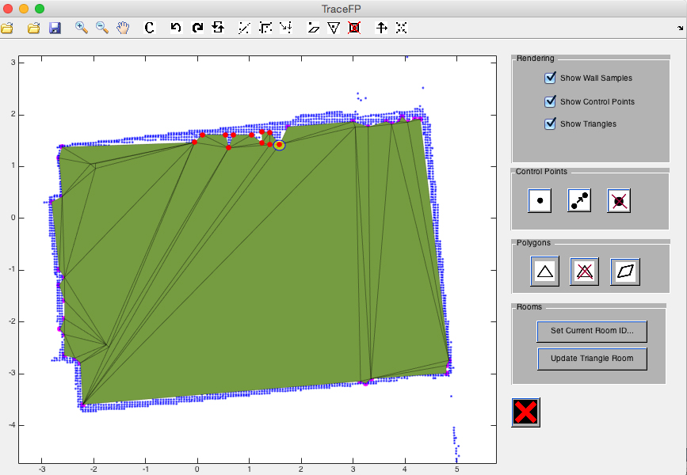

**Remove point(s) from the floor plan**

To remove one or more points from the floor plan, click on the “remove point” button (as indicated below). Then, click and drag over any number of points to remove. User can repeatedly click and drag to remove points in different locations of the floor plan to remove multiple sets of points. Any triangle associated with removed points will also be removed.

User can exit remove points by right clicking anywhere on the floor plan.

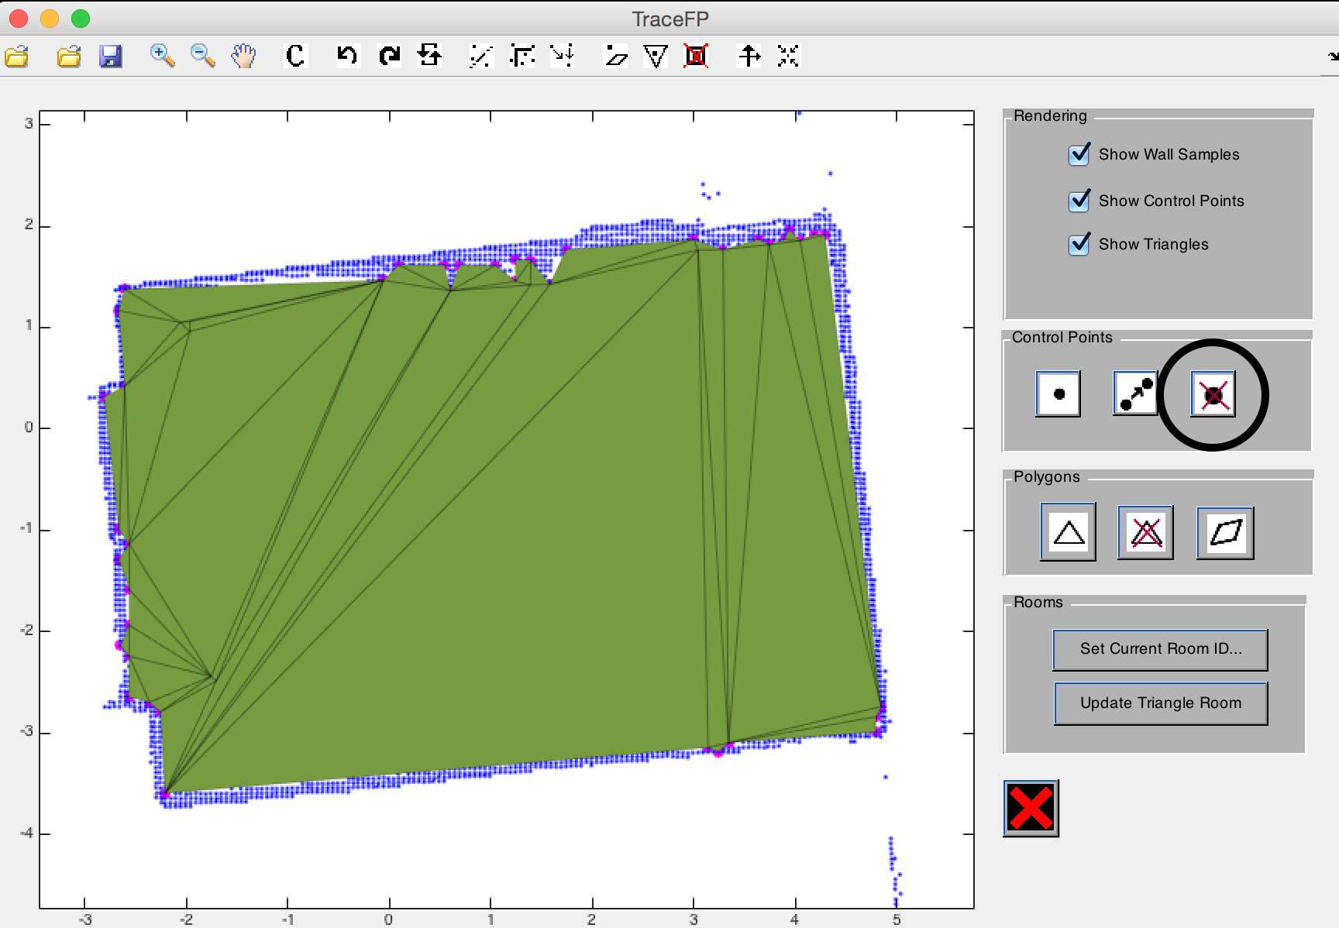



**Basic room manipulation**

**Construct triangle(s) for a room**

To construct a new triangle for the current working room, click the “construct triangle” button (as indicated below), and then click and drag to select three points for constructing the triangle. User can right click to exit this functionality anytime.

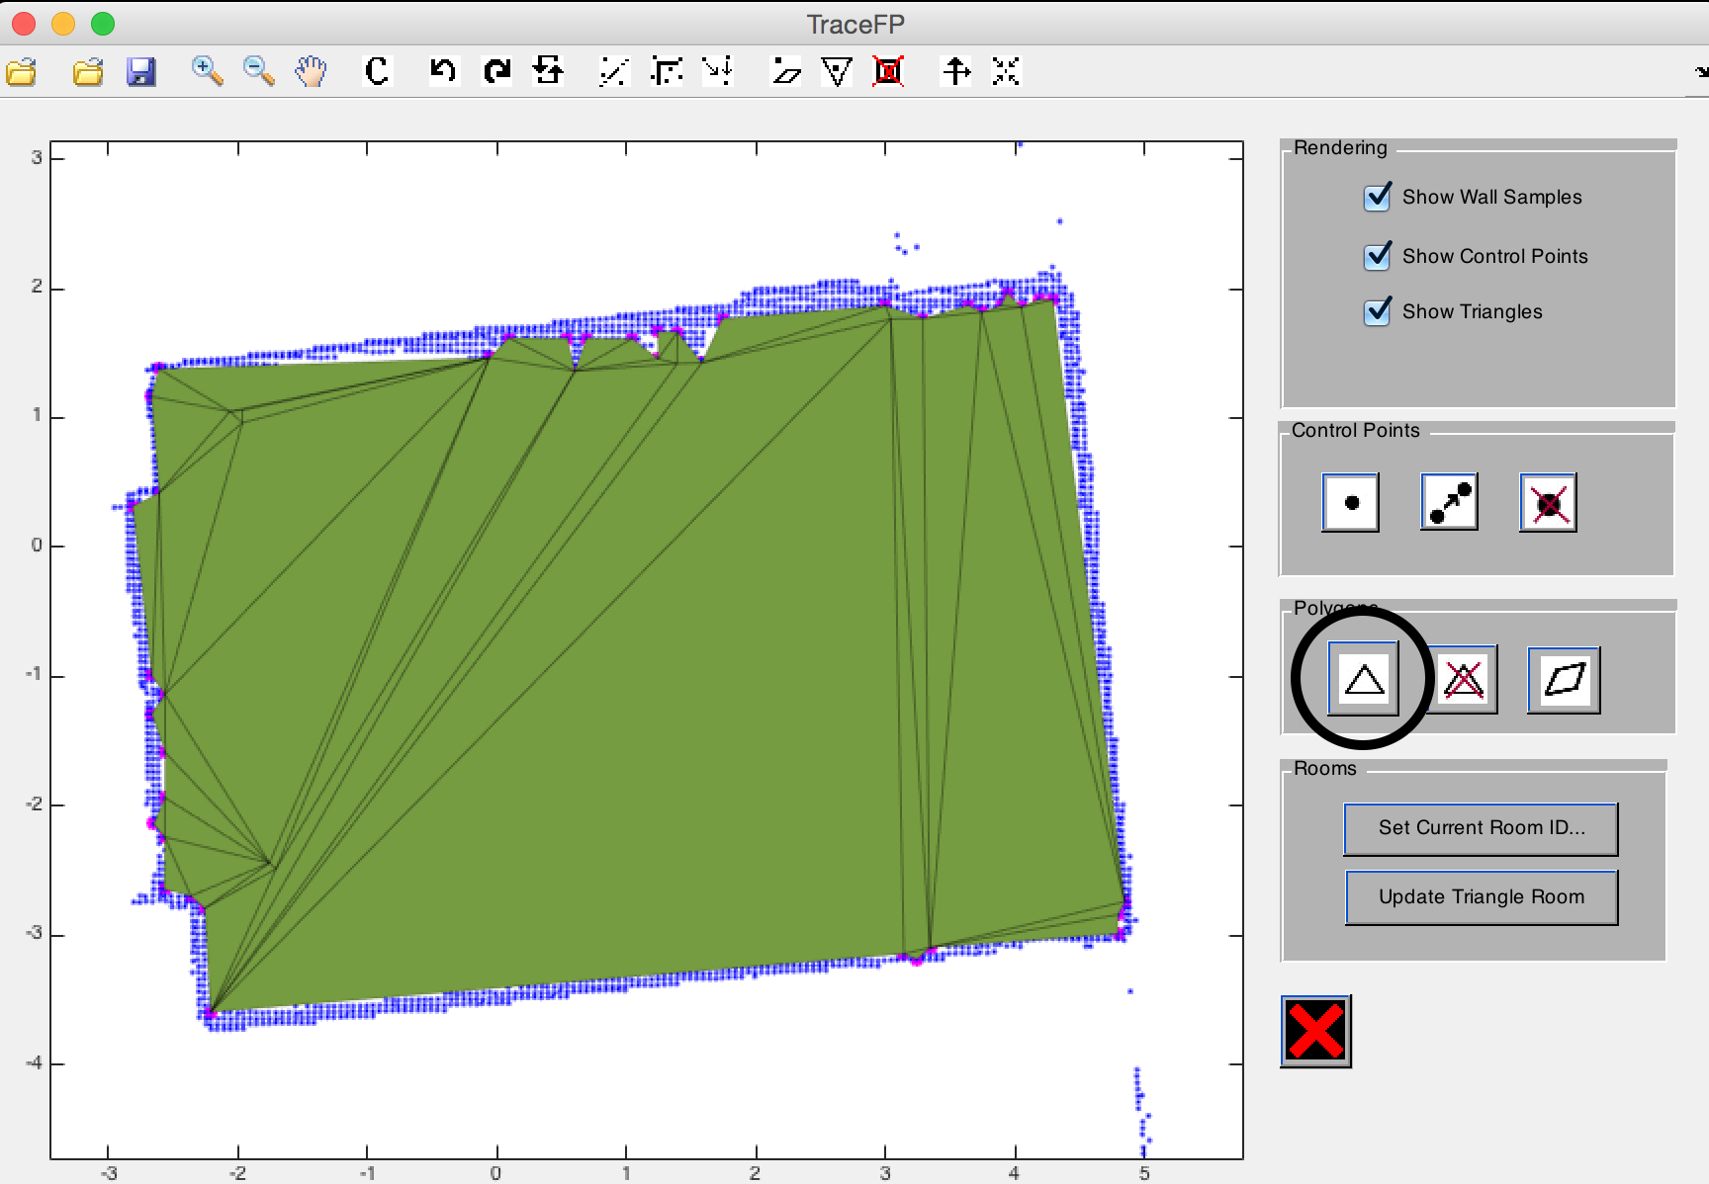

**Remove triangle(s) from a room**

To remove triangles from the current floor plan, click the “remove triangle” button (as indicated below), and then click on all the triangles they would like to remove. User can right click to exit this functionality anytime.

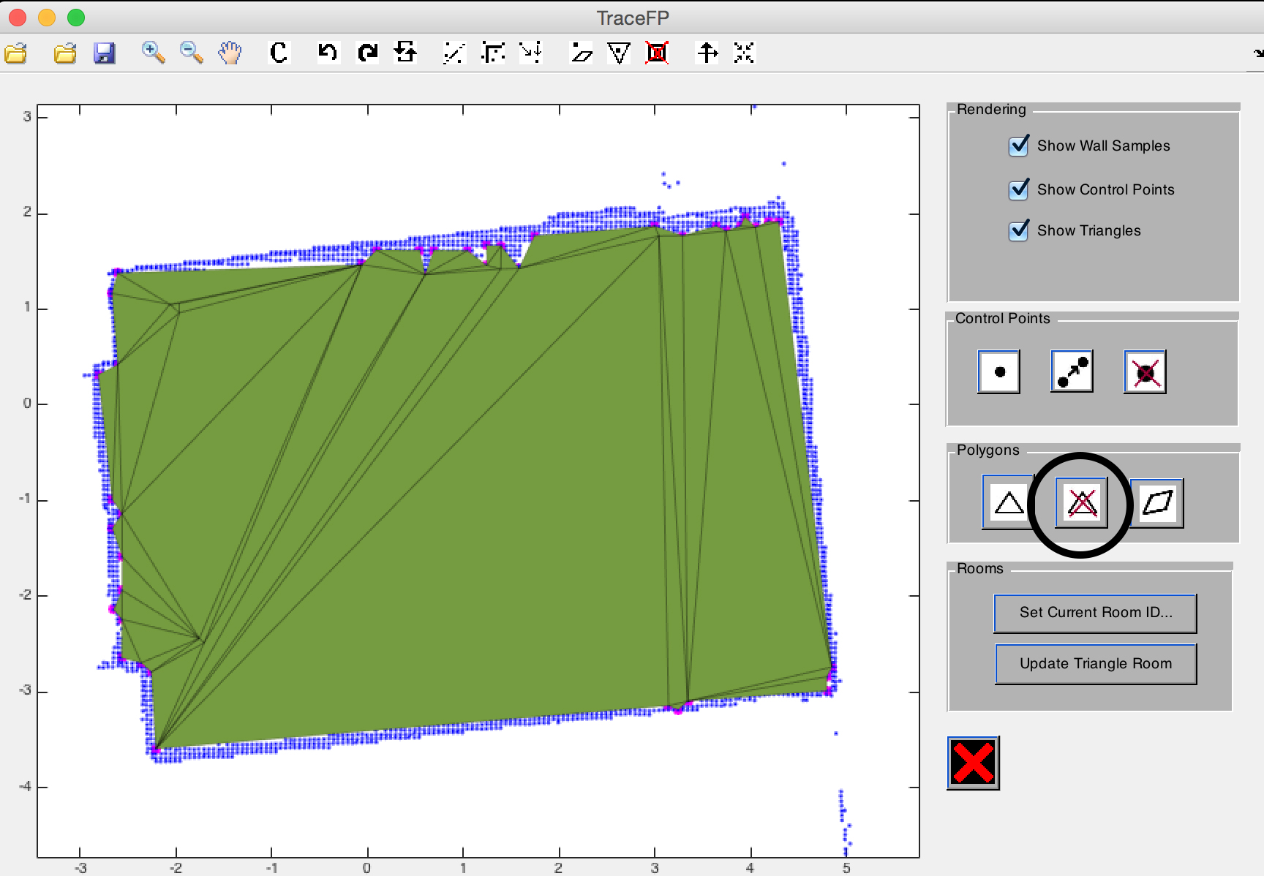

**Construct convex polygon(s) for a room**

To construct a new triangle for the current working room, click the “construct triangle” button (as indicated below), and then click and drag to select a set of points. Triangles will be filled among those points without overlapping each other until the space bounded by those points is completely covered by triangles from the current room. User can right click to exit this functionality anytime.

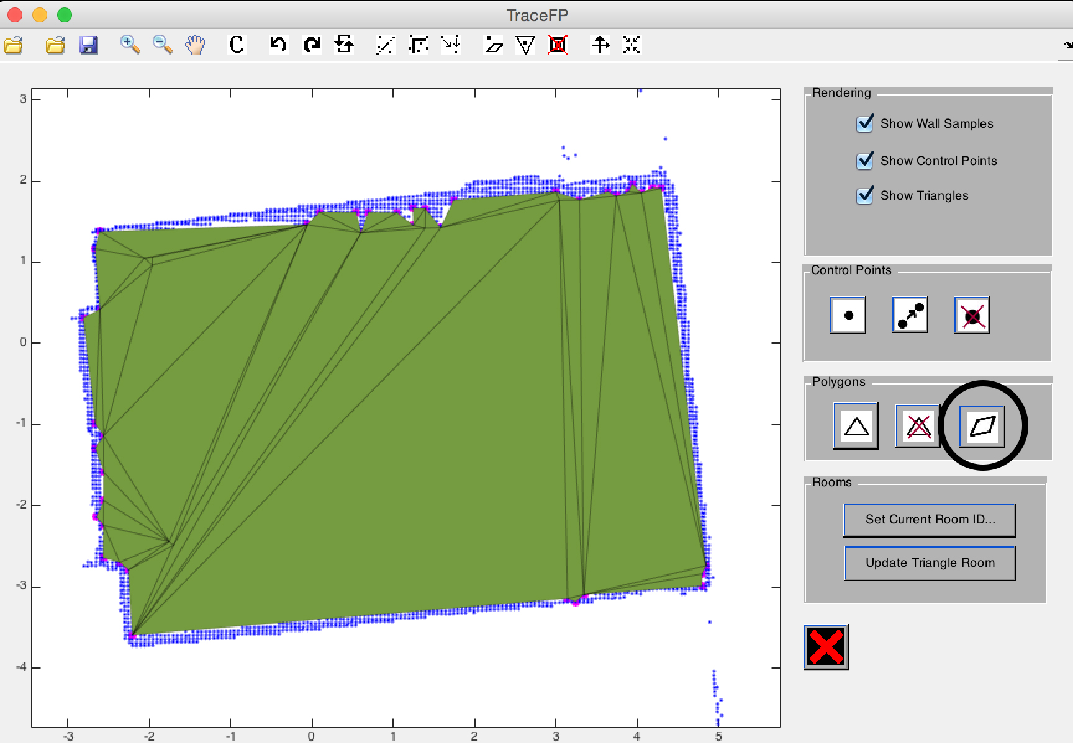

“construct triangle” button will map the points on left to that on the right.

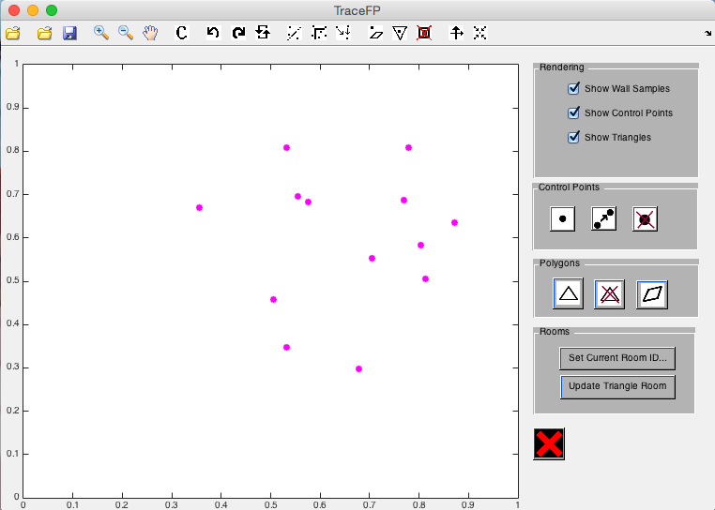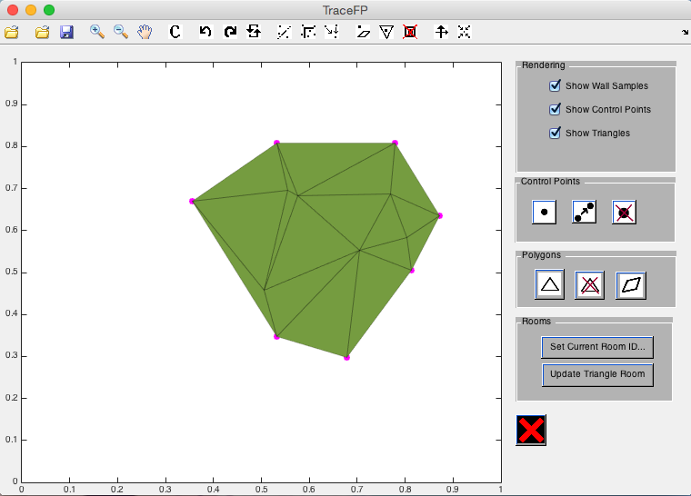

**Undo / Redo**

User can undo or redo their action by clicking the undo / redo buttons (as indicated below).

Redo: button with the leftlefts pointer

Undo: button with the rightwards pointer

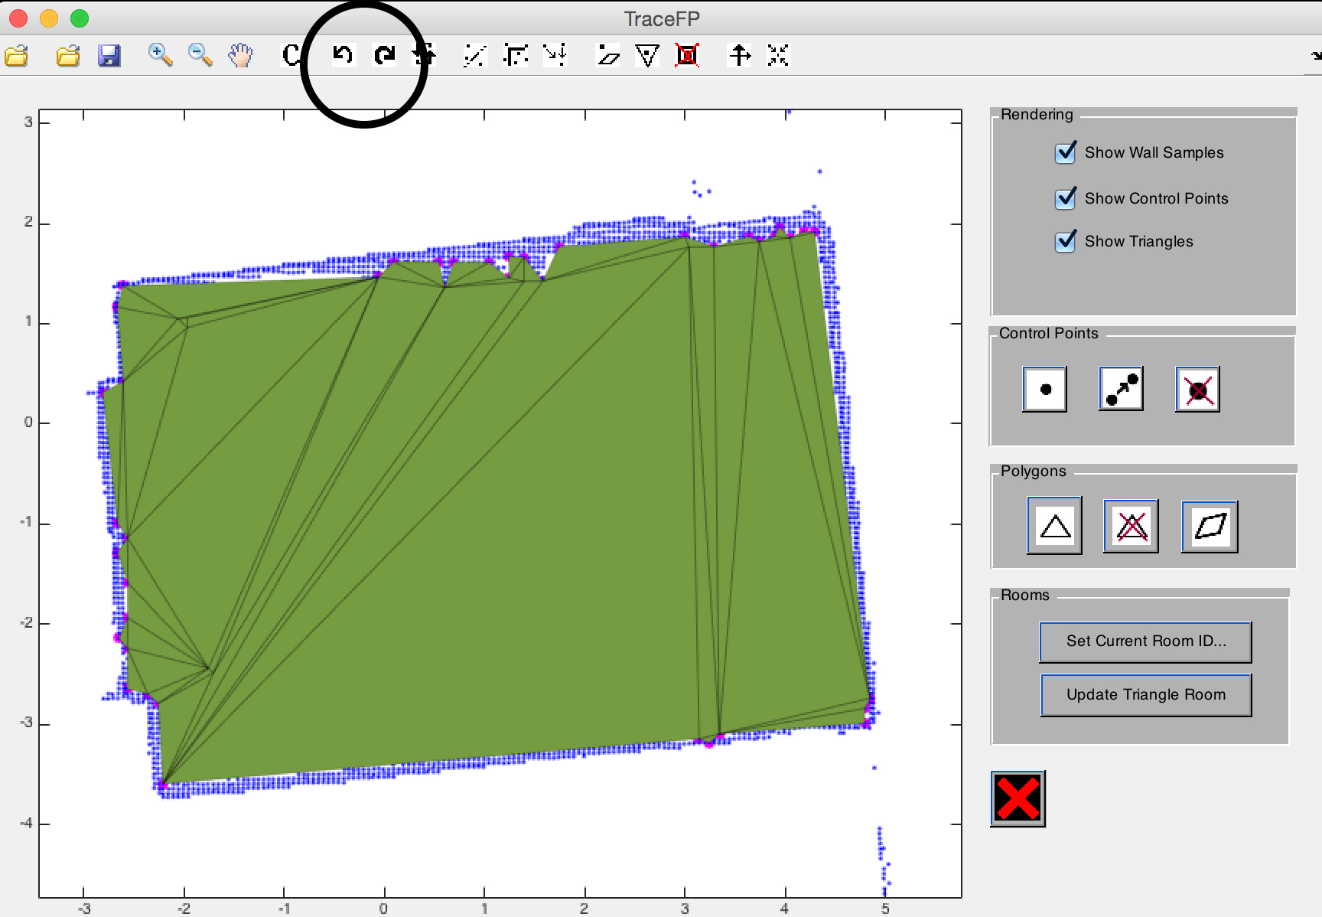

**Advanced floor plan manipulation**